PARAMETRIC STUDY OF PLASMA ENHANCED SHIELDED METAL ARC WELDING PROCESS
Sunil Pandey, S. Thiruchitrambalam*, Dinesh Kumar Shukla* Manoj Kumar* and Anchal Sondhi**
Professor, *Research Scholar, **UG Student,
Department of Mechanical Engineering, Indian Institute of Technology, New Delhi 110016
spandey@mech.iitd.ernet.in
ABSTRACT
The conventional practice for welding cross-country pipelines is using cellulosic electrodes for deeper weld penetration. However, with the use of cellulosic electrodes results in high weld metal hydrogen inducement causing embrittlement of the weld. The use of Plasma Enhanced Shielded Metal Arc Welding (PESMAW) process, a process developed and patented by IITD ensures higher weld penetration and superior microstructure in terms of higher percentage of acicular ferrite and grain refinement with rutile and basic coatings. In the case of welding cross-country pipelines, the weld efficiency and economy achieved by PESAMW is higher then any other available processes. Since the pipelines transport precious and flammable fluids at high pressure, interruption in the transportation system severely affects the output of the industry. Sudden failures of welded joint are undesirable for the industries in the terms of capital as well as loss of human life due to accidents.
This reports the effect of welding current, welding speed, gas flow rate, and the electrode angle on weld bead geometry. Two level half-fractional factorial designs of eight runs were selected for developing the correlations. The models developed were checked for their adequacy and significance by using ‘F-test’ and student’s ‘t’ test. Useful predictions can be made on the basis of the model developed.
Key words: Pipeline welding, Weld bead geometry and shape relationships, PESMAW.
INTRODUCTION
Shielded Metal Arc Welding (SMAW) is a process which uses flux covered electrodes to carry an electric current which is responsible for the melting of both the electrode and the base metal. SMAW is the most widely used welding process because of its low cost, flexibility and versatility. The basic classification of the electrode coating covers cellulosic, rutile, basic and acidic. The conventional practice for welding pipes is with cellulose-coated electrodes. In SMAW of pipes, the engineers facing a lot of problems related to the weld penetration and joint reliability. The result of using the conventional method leads to cold cracking and H-cracking. To overcome this, the use of gas-assisted plasma is incorporated to get the desired penetration with the use of rutile-coated electrodes. In the cellulosic type of coating deeper penetration is achieved by the exothermic reaction of organic materials. Plasma, in Plasma Enhanced Shielded Metal Arc Welding (PESMAW) provides deeper penetration as well as grain refinement of the weld material. In case of welding cross-country pipelines the weld efficiency and economy achieved by PESAMW is higher then any other available processes. Since the pipelines transport precious and flammable fluids at high pressure, interruption in the transportation system severely affects the output of the industry. Sudden failures of welded joint are undesirable for the industries in the terms of capital as well as human lose due to accidents.
DESIGN OF EXPERIMENTS
Two level half-fractional factorial design of eight runs was selected for finding the effect of independent parameters on weld penetration behaviour. The conventional method of finding the performance by varying one of the parameter at a time requires more number of runs and the desired information regarding the interaction between the parameters is also not available. The selection of two level half-fractional factorial design also helps in reducing the trial runs.
The extreme values of the parameters on either side were taken as two levels for the each parameter. The selection of the extreme values was based on the equilibrium condition after conducting a number of experiments. Remaining all the process parameters were kept constant. Welding parameters were designated as (+) and (-) instead of (+1) and (-1) respectively for the higher and lower level. The various parameters with respective limits are given in table 1.

Table-1: Welding parameters.
Parameters | Units | Symbol | Notation | Limits
 |  |  |  | Lower | Upper
Welding current | A | I | 1 | 80 | 110
Weld speed | m/min | S | 2 | 120 | 240
Gas flow rate | l/min | F | 3 | 0.6 | 1.2
Electrode angle | degrees | θ | 4 | 60 | 90
EXPERIMENT
The experiment was conducted on a specially designed semiautomatic setup. Weld beads were deposited using a “bead on plate” technique on a 150*50*6 mm plain carbon steel plate using 6013 rutile-coated hollow electrodes φ3.15 mm. A constant current rectifier type power source with a current capacity of 130A at 100% duty cycle was used. The plates were mechanically cleaned to remove the oxide layers and any foreign matters. Three set of experiments were conducted as per the design matrix and the experiment runs were conducted at random to eliminate the symmetric error. Two set of reading were used for calculating the variance of optimization parameter, the third set was used to calculate the variance of adequacy of the model. Then the two variances were used to calculate the ‘F’ ratio test of the developed model.

DEVELOPMENT OF MATHEMATICAL MODEL
The model of the type P= ƒ {I, S, F,θ} was selected to develop the relationship between the penetration as a response parameter and a particular set of direct process parameters:
Y = b₀ + b₁ I + b₂ S + b₃ F + b₄ θ + b₁₂ IS + b₁₃ IF + b₁₄ Iθ + b₂₃ SF+ b₂₄ Sθ + b₃₄ Fθ
The design Matrix selected for the conduct of trial runs is given in table 2. The half-fractional factorial design of eight runs provides estimates for the effects of four input parameters on the penetration.

Table-2: Design matrix for experimentation.
S No | b₀ | b₁  I | b₂  S | b₃  F | b₄  θ | b₅  IS=Fθ | b₆  IF=Sθ | b₇  Iθ=SF | P΄ | P˝ | P˝΄
 | + | + | + | + | + | + | + | + | 1.4 | 1.4 | 1.15
 | + | - | + | + | - | - | - | + | 1.1 | 1.5 | 0.95
 | + | + | - | + | - | - | + | - | 1.35 | 1.3 | 1.3
 | + | - | - | + | + | + | - | - | 1.0 | 1.15 | 0.9
 | + | + | + | - | + | + | - | - | 1.5 | 1.1 | 1.15
 | + | - | + | - | - | - | + | - | 0.95 | 1.2 | 1.1
 | + | + | - | - | - | - | - | + | 1.2 | 1.35 | 1.55
 | + | - | - | - | + | + | + | + | 0.6 | 0.6 | 0.55
The regression coefficients of the selected model were calculated by the method of least squares. The calculated coefficients of the model are given in table 3.

Table- 3: Coefficients of the model.
Coefficient | Due to | Penetration | Dilution | Width | Reinforcement
b₀ | Combined effect | 1.17 | 41.87 | 8.09 | 1.58
Main effects
b₁ | Welding current | 0.16 | 3.98 | 0.91 | -0.06
b₂ | Weld speed | 0.10 | 5.1 | -0.99 | -0.27
b₃ | Gas flow rate | 0.11 | 2.62 | -0.61 | -0.12
b₄ | Electrode angle | 0.04 | -2.4 | 0.59 | 0.09
Interaction effects
b₅ | 12=34 | -0.08 | -0.8 | -0.41 | -0.01
b₆ | 13=24 | -0.07 | -6.42 | -0.69 | 0.04
b₇ | 14=23 | -0.03 | -2.28 | -0.09 | 0.03
The relationship between weld penetration and the direct input parameters is written in the form of a polynomial by taking into account all possible interactions. The developed model for the prediction of weld penetration is as:
Y_{P} = 1.17 + 0.16 I + 0.10 S + 0.11 F + 0.04 θ - 0.08 IS - 0.07 IF - 0.03 Iθ - 0.03 SF - 0.07 Sθ - 0.08 Fθ
After confounding the equation becomes:
Y_{P} = b₀ + b₁ I + b₂ S + b₃ F + b₄ θ + b₅ IS + b₆ IF + b₇ Iθ
Y_{P} = 1.17 + 0.16 I + 0.10 S + 0.11 F + 0.04 θ - 0.08 IS - 0.07 IF - 0.03 Iθ
Similarly the equation for dilution (%D), width and reinforcement
Y_{%D} = 41.87+ 3.98 I + 5.1 S + 2.62 F -2.4 θ - 0.8 IS - 6.42IF -0.09 Iθ
Y_{W} = 8.09 + 0.91 I - 0.99 S - 0.61 F + 0.59 θ - 0.41 IS - 0.69 IF - 0.09 Iθ
Y_{R} = 1.58 - 0.06 I - 0.27 S - 0.12 F + 0.09 θ - 0.01 IS + 0.04 IF + 0.03 Iθ
ADEQUACY OF THE MODEL
The adequacy of the model was determined by the analysis of variance technique. The regression coefficients were found by the method of least squares, from which the ‘F’ ratio for the polynomials was found. Table 4 and 5 gives the procedure for calculating the variance
Table- 4: Calculations of variance of parameters (s_{i}²)
S No | Penetration |  |  | ΔP= P΄- P˝ | (ΔP)² | s_{i}²
S No | P΄ | P˝ | P˝΄ | ΔP= P΄- P˝ | (ΔP)² | s_{i}²
 | 1.4 | 1.4 | 1.15 | 0 | 0 | 0
 | 1.1 | 1.5 | 0.95 | 0.2 | 0.04 | 0.08
 | 1.35 | 1.3 | 1.3 | -0.025 | 0 | 0
 | 1.0 | 1.15 | 0.9 | 0.075 | 0.01 | 0.01
 | 1.5 | 1.1 | 1.15 | -0.2 | 0.04 | 0.08
 | 0.95 | 1.2 | 1.1 | 0.125 | 0.02 | 0.03
 | 1.2 | 1.35 | 1.55 | 0.075 | 0.01 | 0.01
 | 0.6 | 0.6 | 0.55 | 0 | 0 | 0
 |  |  |  |  | 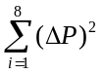=0.11 | 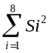=0.22

of optimization parameter and testing of homogeneity of variance using Cochran’s test. Table 6 was used to calculate the ‘F’ ratio. The calculated value was compared with the corresponding ‘F’ ratio from standard table for the 95% level of confidence. Details of analysis of variance are given in table 7.

Table- 5: Homogeneity of variances for Cochran’s test.
∑ s_{i}² | Highest value of variance | Value of Cochran’s criteria (G) |  | Homogeneous
 |  | Experimental (G_{E}) | Tabulated (G_{T}) | Whether G_{E} <G_{T}
0.08 | 0.22 | 0.08/0.22 = 0.37 | 0.68 | Yes
3442.01 | 5504.56 | 0.6253 | 0.68 | Yes
1.05 | 2.68 | 0.39 | 0.68 | Yes
0.245 | 0.36 | 0.66 | 0.68 | Yes

Table- 6: Variance of adequacy (S²_{ad}).
S No | Penetration (P) |  | Δp = P˝΄ - P˜ | (Δp)²
 | Estimated value, P˜ | Observed value, P˝΄
 | 1.40 | 1.15 | 0.25 | 0.063
 | 1.30 | 0.95 | 0.35 | 0.123
 | 1.325 | 1.30 | 0.025 | 0.000625
 | 1.075 | 0.90 | 0.175 | 0.031
 | 1.30 | 1.15 | 0.15 | 0.023
 | 1.075 | 1.10 | -0.03 | 0.000625
 | 1.275 | 1.55 | -0.28 | 0.076
 | 0.60 | 0.55 | 0.05 | 0.002
 |  |  |  | =0.318

Table- 7: Analysis of variance for weld penetration
Degree of freedom |  | Variance of response | Standard deviation of coefficients | Variance of adequacy | ‘F’ ratio model | ‘F’ ratio table | Adequacy of model
S₁² | S²_{ad} | s_{i}² | s_{bj} | s²_{ad} | F_{m} | at 3.8,0.05 | F_{m} < F_{t}
8 | 3 | 0.215 | 0.058 | 0.106 | 0.49 | 4.1 | Yes
8 | 3 | 41.63 | 2.28 | 111.03 | 2.67 | 4.1 | Yes
8 | 3 | 0.33 | 0.20 | 0.89 | 2.67 | 4.1 | Yes
8 | 3 | 0.05 | 0.07 | 0.12 | 2.67 | 4.1 | Yes
ANALYSIS OF RESULTS
The significance of coefficients was tested by the student‘t’ test. Coefficients having values less then or equal to ‘t’ value were insignificant. Higher the value of ‘t’ is recommended for significance. The value of ‘t’ for eight degree of freedom from table (8,0.05) is 2.3. Table 8 gives the calculated values of ‘t’.
Table- 8: Student ‘t’ test values for the coefficients
Coefficient | Due to | ‘t’ value
Coefficient | Due to | Penetration | % Dilution | Width | Reinforcement
b₀ | Combined effect | 20.2 | 18.35 | 39.51 | 20.83
Main effects
b₁ | Welding current | 2.69 | 1.74 | 4.46 | -0.74
b₂ | Weld speed | 1.72 | 2.3 | -4.82 | -3.54
b₃ | Gas flow rate | 1.83 | 1.15 | -2.99 | -1.56
b₄ | Electrode angle | 0.65 | -1.05 | 2.87 | 1.24
Interaction effects
b₅ | 12=34 | -1.30 | -0.35 | -2.02 | -0.08
b₆ | 13=24 | -1.19 | -2.81 | -3.36 | 0.58
b₇ | 14=23 | -0.43 | -1.00 | -0.43 | 0.41
The proposed model for the prediction of welding penetration after dropping the statistically insignificant coefficients is:
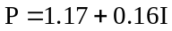
W = 8.09 + 0.91 I - 0.99 S - 0.61 F + 0.59 θ - 0.69 IF
%D = 41.87 + 5.1 S - 6.42IF
R = 1.58 - 0.27 S

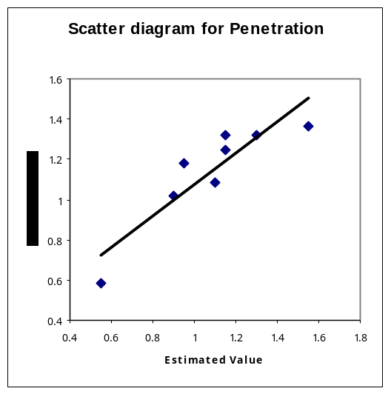 | 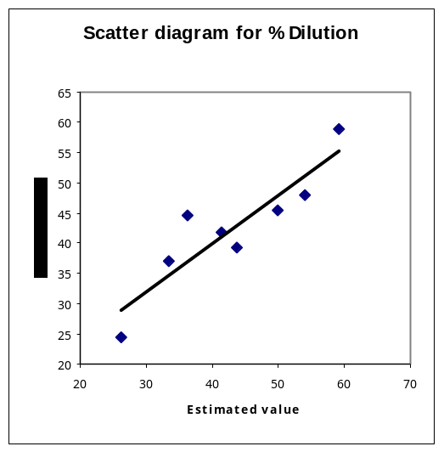
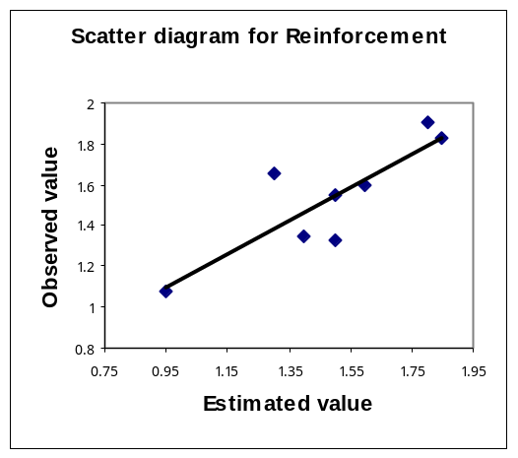 | 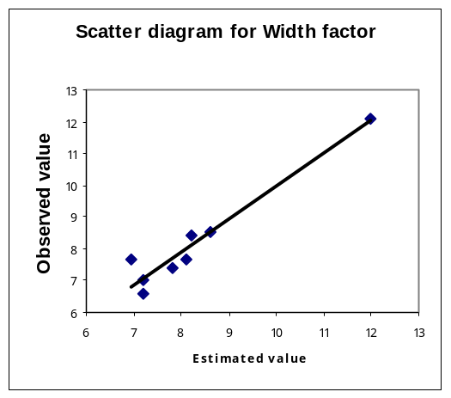
Figure- 1: Scatter diagram for Penetration.
The hypothesis adopted for identifying the parameters, which were mainly and predominantly responsible for the interaction effect in a confounded pattern was to first drop those interactions that were due to the parameter having insignificant effects and if there were still two or more interactions left in the confounded pattern then the interaction due to parameter which the most predominant effect was selected.
The main effect due to the welding current is mainly responsible for calculating the weld penetration.
Figure- 1 shows the adequacy of the proposed model at 5% significance level by the means of a scatter diagram.
CONCLUSION
It was concluded from the analysis that the major parameter affecting the penetration level is welding current. The combined effect of the process ie gas plasma, feed rate and welding speed have also the significant seen in the constant parameter of the equation. Results show that with the increase in current the penetration will increase three to four times as compared to conventional SMAW process. The effect of welding speed on the percentage dilution is significant and was mentioned in the modelled equation. The width component of the bead geometry and shape relationship was mainly governed by the input current parameter.
REFERENCES
- Adler Y.P., Markov E.V., Granovsky Y.V. 1975, “The Design of Experiments to find optimal conditions”, MIR publishing, Moscow,.
- Connor L.P. 1991 “Welding Handbook”, American Welding Society Eighth edition, 1,.
- Khan Tahir I., Pandey Sunil, Thiruchitrambalam. S, 2003, “Surface modification of steels using plasma enhanced shielded metal arc welding process (PESMAW)”, International welding symposium on emerging trends in welding, Hyderabad, India.
- Nadkarni S.V. 1988, “Modern arc welding technology”, Advani Oerlikon Ltd.
- Pandey Sunil, Khan Tahir I., Thiruchitrambalam. S, April 2003 “Surface modification of steels using plasma enhanced shielded metal arc welding process (PESMAW)”, Indian welding journal,.
- Pandey Sunil 2004, “Welding current and melting rate in submerged arc welding: a new approach”, Australasian welding journal- vol. 49(2); 33-42.
- Thiruchitrambalam. S, Pandey Sunil, 2004 “Some studies on Plasma enhanced shielded metal arc welding (PESMAW) of mild steel”, SOJOM Trichy, India.
- Walpole, Myers, Myers, Ye: “Probability & Statistics for engineers & Scientists”, Pearson Education, 7th ed.

